**PJ 4 Report My Name: __Yaowei Lei_**

**A. The following is my Python source program:**

**// Please copy your source program into here from your Visual Studio IDE.**

**// Your code here must be in color. You must not show screen prints here.**

#-------------------------------------------------------------------------------------------------------.

# Author: Yaowei Lei

# Date: 10/28/2021

# Purpose: CS119-PJ4: A game to roll the dice and earn/lose money with initial money of 100 dollars

# for you to start your game.

#-------------------------------------------------------------------------------------------------------.

# MAIN PROGRAM: ============================================.

import random

n = 1 # line number for each separator line in sequence

print("Welcome to the Rolling Dice Game of Yaowei Lei!" ) # must use your name

print(n,"=========================================================."); n+=1;

yourMoney = 100

print( "Now, you have ", yourMoney, "dollars to play the game.")

while True: # keep running forever. It must be stopped by a break inside the loop.

print(n,"=========================================================."); n+=1;

bet = int(input("Enter your bet to roll the dice (enter 0 to quit): ")) # get bet

# if bet is zero:

# we must break out of this loop immediately to end the game;

if bet == 0:

break

dealer = random.randint(1, 6) # dealer rolls the dice

you = random.randint(1, 6) # you roll the dice

print("Dealer got ", dealer, ", and you got ", you, "." )

# if dealer’s points is more than yours:

# subtract the bet from your money since you lost;

if dealer > you:

yourMoney -= bet

print("You lost " , bet, " dollars. Now, you have ", yourMoney, " dollars. ")

# otherwise if dealer’s points is less than yours:

# add the bet to your money since you won;

elif dealer < you:

yourMoney += bet

print( "You won. Now, you have ", yourMoney, "dollars.")

# your statements

# otherwise (It must be a tie, therefore, you won or lost nothing.)

else:

print("It's a tie. Now, you have ", yourMoney, "dollars.")

# end of while True loop

print(n,"=========================================================."); n+=1;

print("Thank you for playing the Rolling Dice Game of Yaowei Lei!") # must use your name

print(n,"=========================================================."); n+=1;

x = input("Press Ctrl+Alt+PrtScn to get a snapshot of this console, then ENTER to exit: ")

# End of MAIN PROGRAM ==========================================.

**B. The following is the console output of my 3 test runs:**

**// Please copy your console output and paste into here:**

**Test Case #1:**

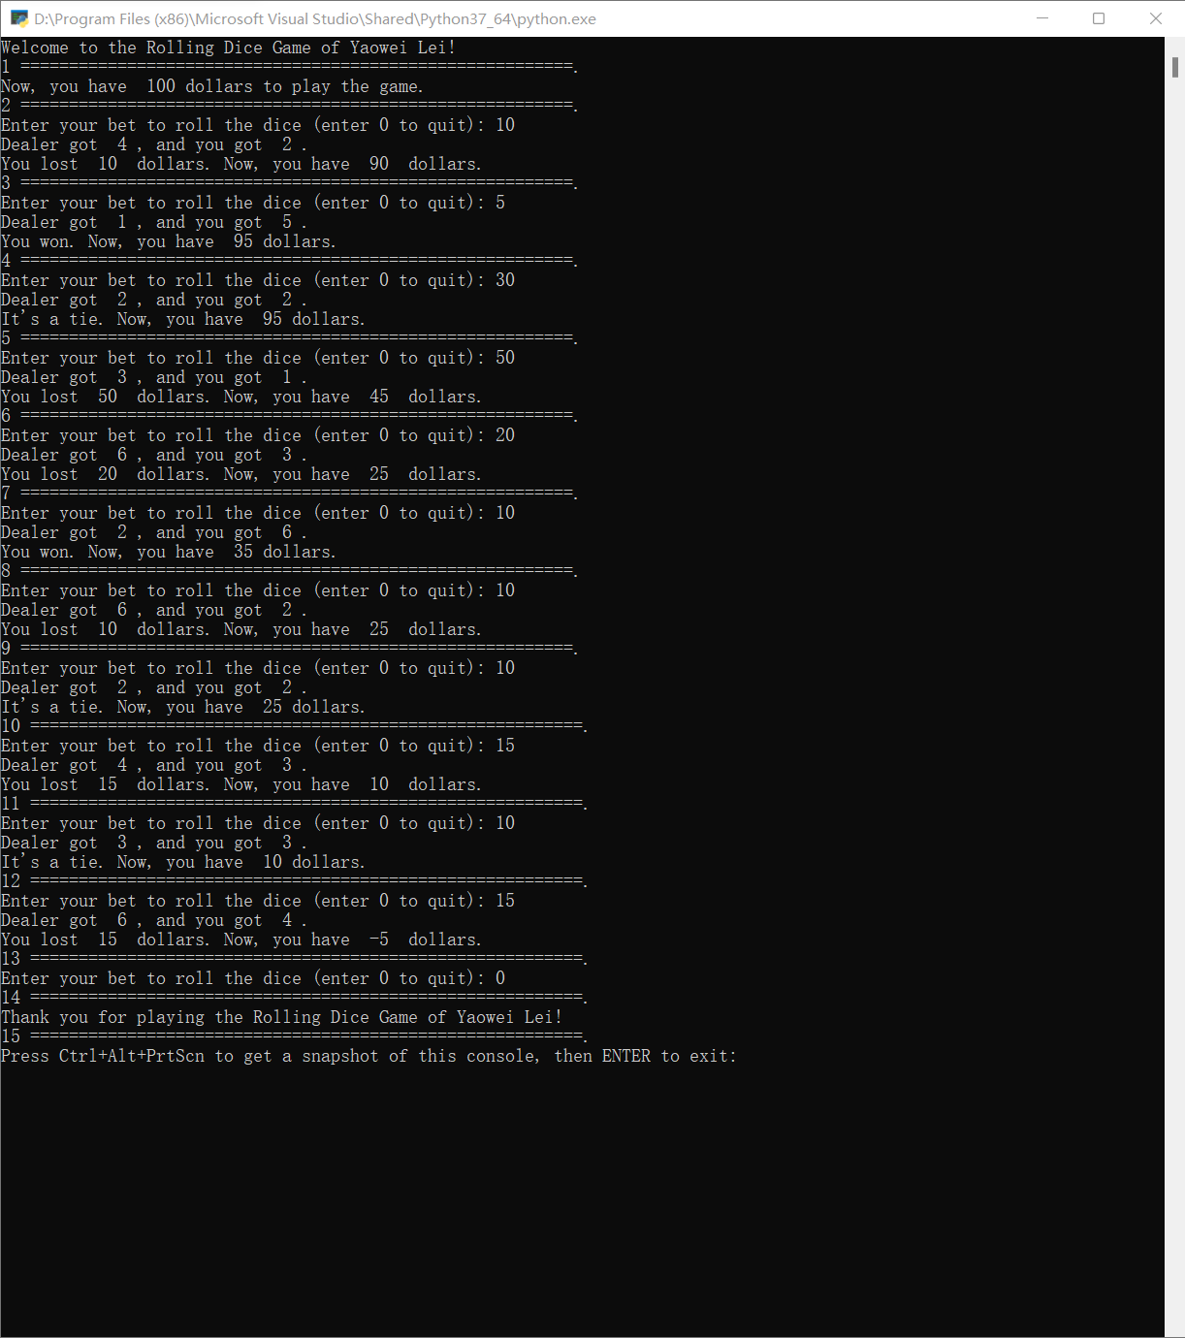

**Test Case #2: At least 7 rounds.**

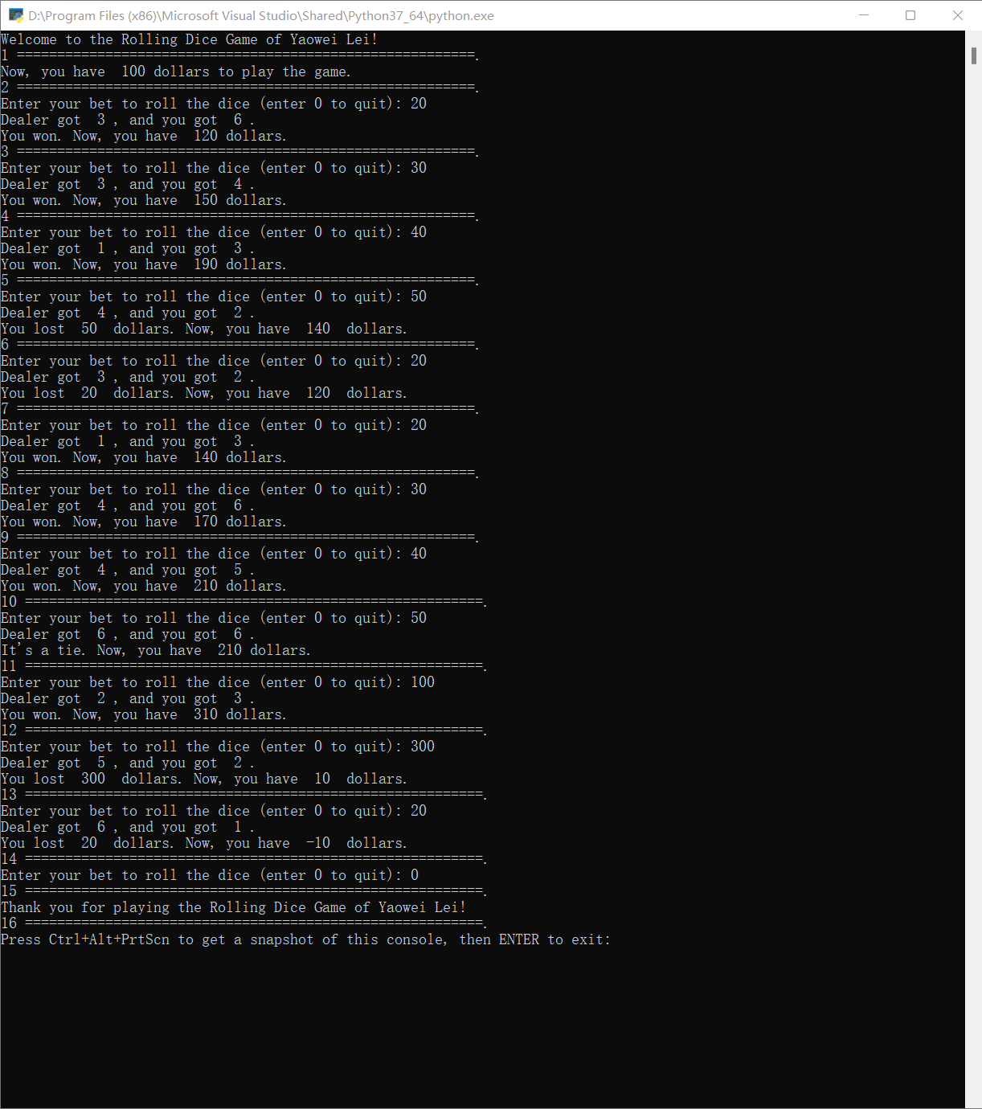

**Test Case #3: At least 7 rounds.**

